Channelization Protocols

1. Channelization: Multiple access method in which the available bandwidth of a link is shared in time, frequency, or through code, between different stations.
2. Multiplexing: Multiple signals are combined together thus travel simultaneously in a shared medium.
3. Multiplexing = sharing the bandwidth
4. Various multiple access methods:
   1. Frequency Division multiple access (FDMA)
   2. Time Division multiple access (TDMA)
   3. Code Division multiple access (CDMA)

FDMA

1. The available bandwidth of the common channel is divided into bands that are separated by guard bands
2. The available bandwidth is shared by all stations.
3. The FDMA is a data link layer protocol that uses FDM at the physical layer.

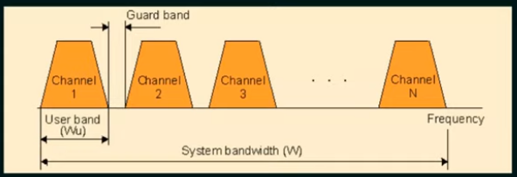

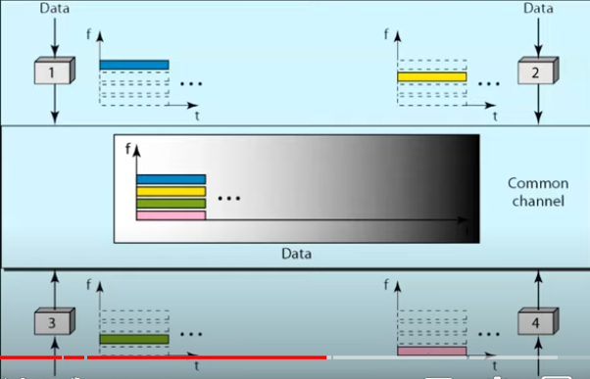

TDMA

1. The bandwidth is just one channel that is time shared between different stations
2. The entire bandwidth is just one channel
3. Stations share the capacity of the channel in time.

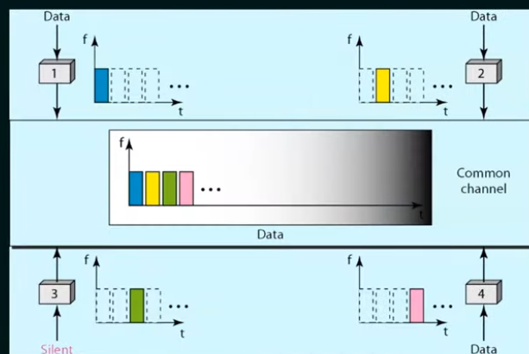

CDMA

1. One channel carries all transmissions simultaneously.
2. CDMA differs from FSMA because only one channel occupies the entire bandwidth of the link.
3. It differs from TDMA because all stations can send data simultaneously, there is no time sharing.

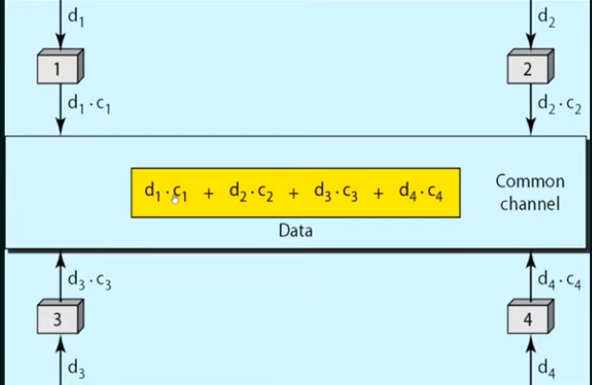

This is multiplexing.

The assigned codes have two properties:

1. If we multiply each code by another, we get 0.
2. If we multiply each code by itself, we get 4(the number of stations)

Example:

Data = d1\*c1+d2\*c2+d3\*c3+d4\*c4 = 4\*d1 (4 is the number of stations)